# LONG LETTER

From:

The Tooth Fairy

321 Sparkle Street

The Enameled Palace

Kingdom of Wisdom Teeth

To: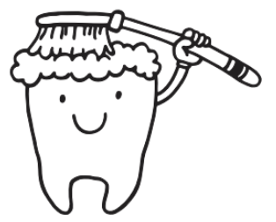

Sweet Sierra

Under The Pillow

Sleepyville, XO

Dear **Sierra**,

Congratulations on losing your tooth. It's quite a gem!

You were very brave. I have been waiting and waiting, just like you!

I am so full of joy that I did a few extra twirls in the air as I flew to your   
house from The Enameled Palace.

Each time you lose a tooth, I will leave a little treat for you under your pillow.

I might even leave a shiny gold bag with a special treasure and a story from Fairyland!

I want you to meet my friend, Lucy Tooth. I got to be in her book.

Remember to brush and floss every day. And don't eat too many sweets because they   
aren't good for your teeth. Besides, you are sweet enough already!

I look forward to next time.

With love and fairy dust sparkles,

Twinkle

Your Magical Tooth Fairy

# SHORT LETTER



Dear Sweet Sierra

While you lay sleeping, I came in the night.  
Near your pillow was a marvelous sight.

Your beautiful tooth has come unstuck.

I'll keep it forever - it will bring you good luck!

Love, Your Magical Tooth Fairy