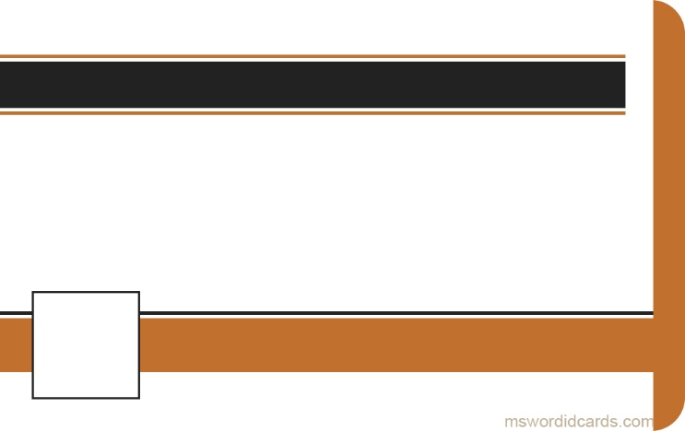

***PRIVATE***

**MOBILE NO:**

**EXPIRED:**

**FEB,2018**

**+1 111 654 7890**

**01 AUG 1985**

**D.O.B:**

**HIS 00AB1234**

**SER NO:**

**INVESTIGATOR**

***FIRST, LAST NAME***