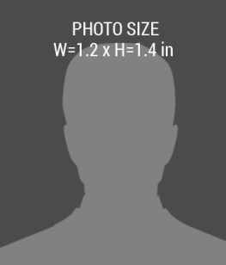barcode.png

**02/02/2017**

**02/02/2018**

PHONE:

EXPIRIES:

ISSUE:

ADDRESS:

**+1 000 888 1111**

**First Name, Last Name**

**Street, City**

**123 Anywhere**

DESIGNATION